Project 2: IC image analysis for counterfeit detection
Objective: The goal is to develop a tool to automatically analyze the image of an IC to identify specific features that are useful for counterfeit detection.
Step 1- Pin defect detection (70%): This step involves using existing image analysis/processing techniques to automatically identify all pins of an IC and then mark (in the image) any inconsistency or defect that may exist. The automation script should take the image as an input and output a new image with consistent pins of the IC marked in a green box and inconsistent pin using red box. You can use any existing programming library/algorithm to implement it. A set of images with one or more inconsistent pin is provided on Canvas.

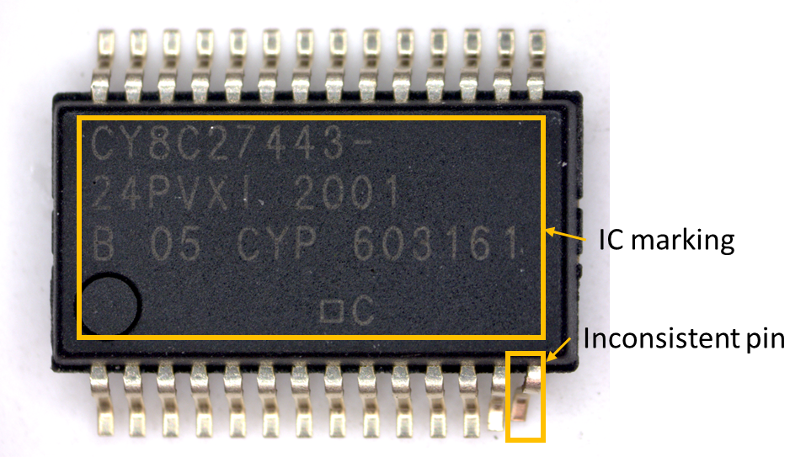
Step 2- IC marking detecting (30%): Write a script to extract the marking text on the surface of the IC automatically and report it. You can use any existing programming library to implement it. A set of images with IC marking is provided on Canvas.
Deliverable:
- Source code of the script for both step 1 and 2,
- Output images with green and red marking,
- Report.
You can use existing codes to implement the algorithms (no need to write from scratch).
Report outline: Objective and motivation, methodology of tool and implementation, results, conclusion, references.

